Reporting - How to create a report from the interactions in a Residents Timeline

To run a timeline report, select administration and then select reports.

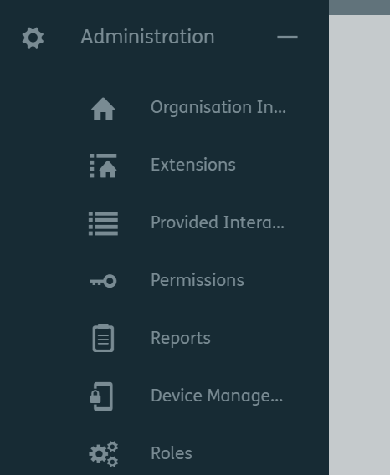
2. Select Reports
- Select Administration
3. Click on the + to create a new report

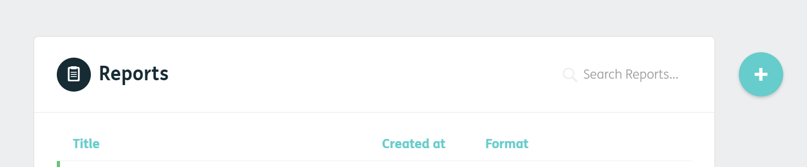

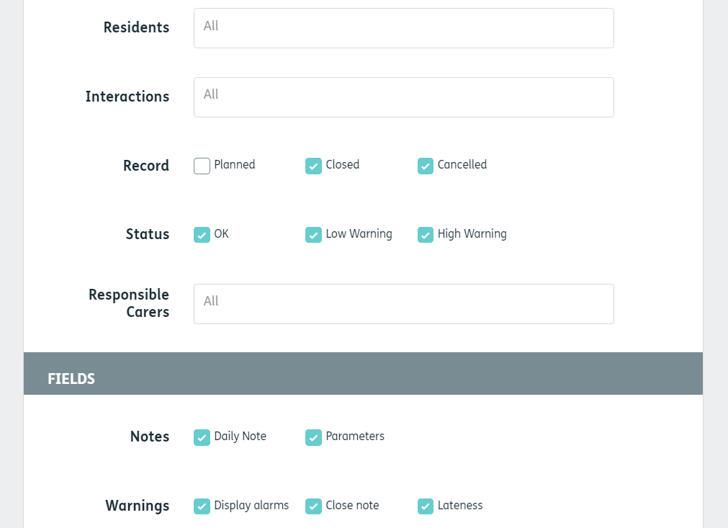
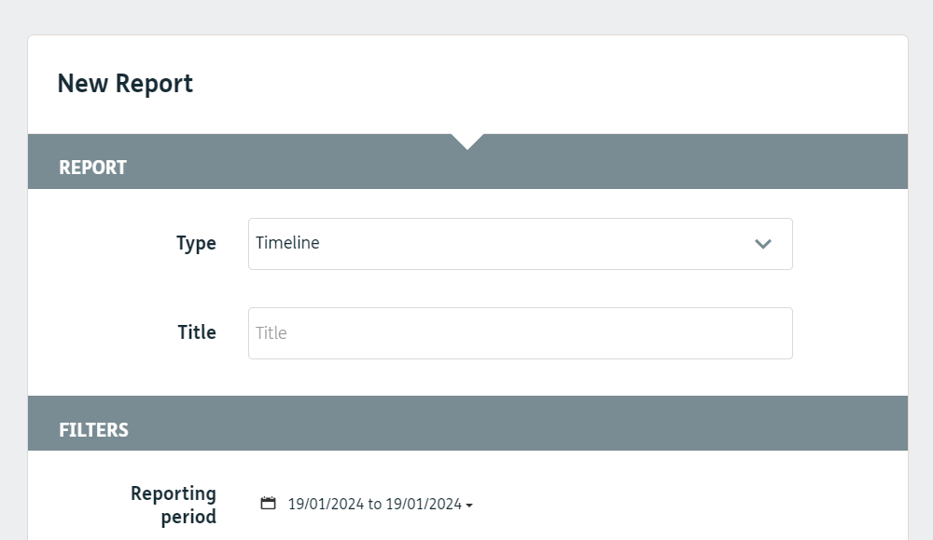
5. Select a date range.
6. Select individual residents or All
4. Give it a title.

7. Select Interactions or All

8. Select Responsible Carer or leave as All

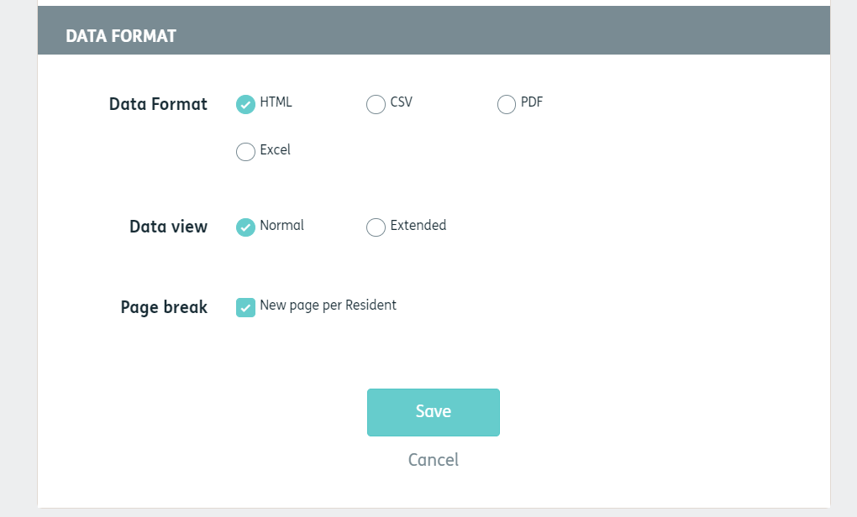
10. Click on save
9. Select format. PDF is good for printing.

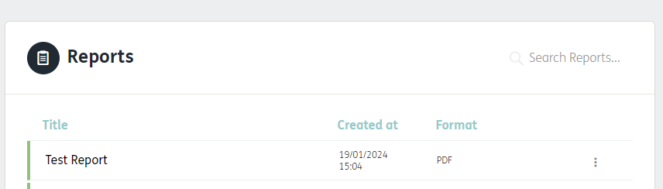
11. Click on the name of the report to open.

